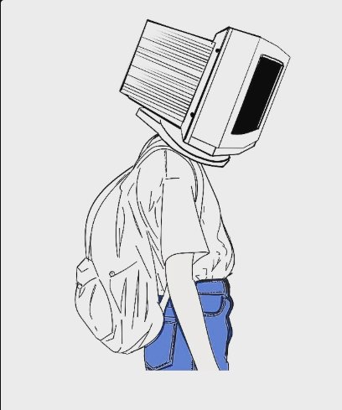
Since childhood,I've been fascinated by technology.I've been privileged enough to have parents,Who could afford quality schooling and provided me with desktops,laptops and smartphones at my wish.

Naturally I had an early exposure to the web.Soon,I figured out there was a vast store of knowledge too,other than gaming and porn on the internet.

Though the priorities never shifted,I started giving more and more time into reading multiple articles and useless(conspiracy) theories.Inside jobs,anarchy,artificial reality,seeds of these concepts,embedded in my subconscious,started to germinate.

I'd take economics classes,and think of jews controlling the world economy,I'd take english classes and think of the subconscious slavery that the east still faces.

I would want more and more of it,confusing entertainment with reality.I started believing this world wasn't real,and that I was part of someone 's experiment who was making me live in a stimulation.

I desperately wanted to break free,so I took a blade,and slowly slid it through my skin.The touch,the first drops of blood,oozing through my skin,the sensation of being cut,it was all so beautiful,and I was unafraid,for it was all a stimulation.

I woke up.

In a hospital.

Blue spots on my forearm.

Stitches on my wrist.

It's been 3 years since I've been doing drugs.
They said the pills were the ultimate gateway to knowledge and the government didn't want us to know.
I gave them my address.

Now I know,knowing too much isn't good.

